

**ST PAUL’S ELC ACTION PLAN**

**TO SUPPORT DELIVERY OF SIP**

**2023 / 2024**



*At St. Paul’s Nursery our vision is to create an inclusive, nurturing environment where children are encouraged to develop their curiosity and creativity through play, supported through sensitive, caring relationships. We aim to inspire lifelong learning through freedom of choice and expression, access to nature and fun. Children’s voices are at the heart of our practice, with respect for children’s rights and responsibilities ensuring that we work as one team. Our child centred approach provides a responsive curriculum, centred around play and the needs and care of our children. We aim to ensure that our children are given the support, space and time they need to develop and grow.*

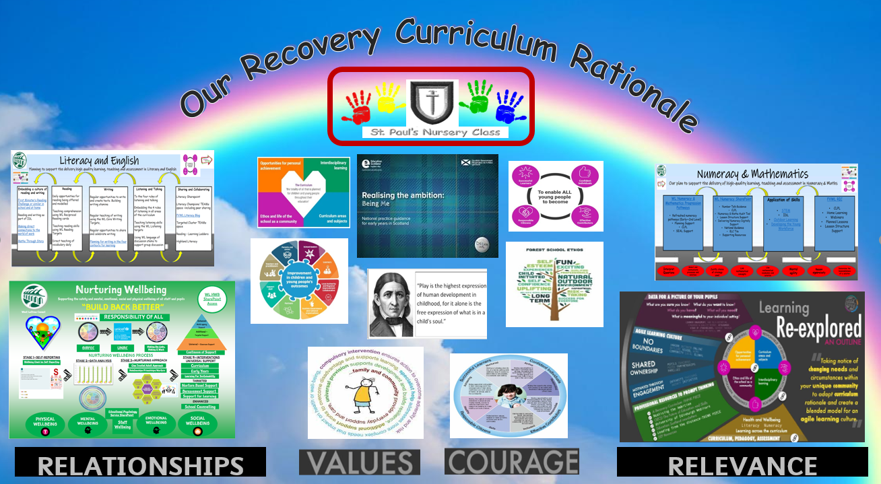

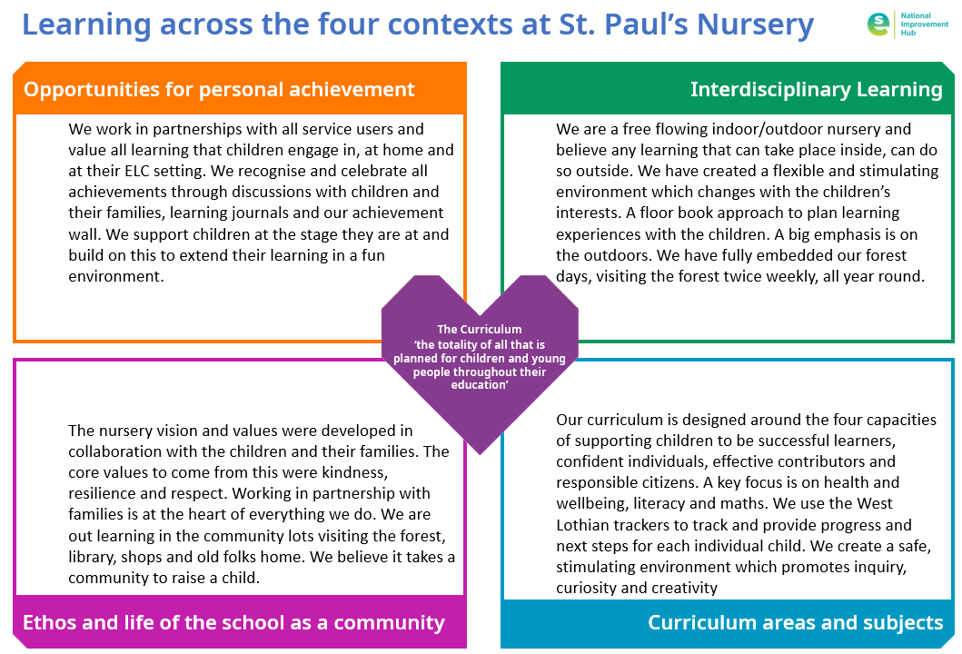

|  |  |  |  |  |
| --- | --- | --- | --- | --- |
| **St. Paul’s Nursery - ELC Improvement Planning for Ensuring Excellence and Equity** | | | | |
| **School priorities linked to knowledge and data as identified on previous page** | **Links to HGIOELC, QFDCCSA*, CNH&SCS,** | **Proposed actions** | **Timescale** | **Measures of Success** |
| **Improvement in all children and young people’s wellbeing:**  **All children to be nurtured and supported and to feel safe and secure**  **in their daily nursery experience** |  | * Further embed the vision, values and aims through consultation with parents * Develop an understanding of a trauma informed approach through participation in Trauma Informed CLPL. Develop a ‘commitment to change’ action plan. * Ensure new staff are trained in the use of a nurture approach and embed practice across the setting * ELC staff to undertake CLPL to support learners’ understanding of the wellbeing indicators and develop children’s’ ability to discuss their feelings through the use of Emotion Works vocabulary. | May 2024  October 2023  May 2024  May 2024 | * Parent feedback on vison, values and aims * Trauma Informed Commitment for Change developed and actioned * Nurturing approaches and language evident through staff interactions with children * All pre-school children will show progress on EC tracker for coping with everyday/new situations |
| **Raising attainment for all, particularly in literacy and numeracy(universal):**  **All children to achieve full potential in literacy and numeracy** |  | * Staff to continue to improve practice in planning for high quality learning opportunities in literacy, numeracy and maths * A new numeracy lead will be appointed to continue to develop the numeracy curriculum and support staff with planning of numeracy activities * Staff to continue to undertake CLPL to help develop observation skills leading to improvements in learning opportunities for children and increased understanding of progression of achievement of a level in literacy and numeracy * Continue to interrogate ELC Tracker data to ensure learners are provided with appropriate learning opportunities and to track learners’ progress * Clear calendar of Quality Improvement activities planned for the session and led by members of SLT * Based on parental feedback, ‘travelling bears’ will be reintroduced to help develop learners’ verbal communication skills * ELC staff will undertake best practice visits with a focus on their Leadership Roles. | May 2024  October 2023  May 2024  Ongoing  September 2023  October 2023  December 2023 | * Quality assurance meetings will evidence learners’ progress over the session * QI meetings show clear links across Daily planning, floor books, consultative planning and learners’ SeeSaw * ELC Trackers will show progress in Literacy and Numeracy for all pre-school learners * Staff feedback will show increased levels of confidence in planning and tracking progress in literacy and numeracy |
| **Tackling the attainment gap between the most and least advantaged children (targeted):**  **To ensure equity for all pupils in a supportive, inclusive environment** |  | * Continue to use systems and procedures to highlight and meet children’s needs effectively, including ASN reviews, use of Assessment of Wellbeing, CPMs and IEPs * Continue to strengthen relationships with partner agencies to support children and their families | Ongoing  Ongoing | * Quality assurance records will evidence high levels of competence in the Health and Social Care Standards * Quality Assurance procedures and practice will evidence Assessment of Wellbeing being used effectively through appropriate professional dialogue and actions and recorded in personal plans and PPR |
| **Improvement in employability skills and sustained, positive school leaver destinations for all young people:**  Children to experience a wide range of interesting and relevant learning experiences in and out with the nursery environment |  | * Refresh the nursery Curriculum Rationale involving all stakeholders * Continue to improve family engagement through a calendar of planned events such as Stay, Play and Learn * Introduce SeeSaw as method of profiling learners’ progress in partnership with parents/carers * Increase ELC staff knowledge of the Early Level Career Standard to enable them to plan appropriate activities * Continue to provide earning opportunities to learn in the community | May 2024  September 2023  September 2023  December 2023 | * Feedback from stakeholders regarding Curriculum Rationale * Quality assurance of Learners’ Profiles on SeeSaw * Qulaty Assurance records will evidence rich learning experiences in the community |

\**Quality Framework for Daycare of Children, Childminding and School Aged Childcare*